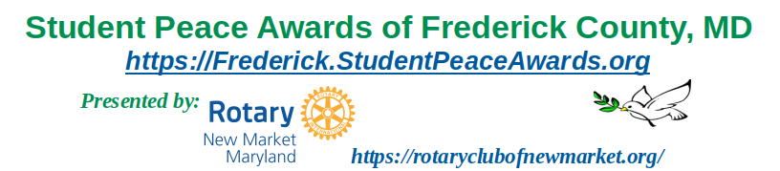
Mission
The Student Peace Awards of Frederick County draw attention to work being done in our community to promote the values of peacemaking, conflict resolution, and respect for all people. The awards honor high school seniors who have demonstrated outstanding compassion, creativity, and commitment. Awardees will be selected based on their efforts to:
- commit to peace by engaging in activities that strive to end conflict locally or globally,
- discuss or find positive resolution to potentially controversial issues within the school or community,
- promote understanding to bridge language, ethnic, racial, religious or class differences,
- resolve conflicts among students or members of the community who feel isolated or alienated.
In choosing awardees, the focus will be on actions, activities and projects, not on written essays. The hope is to honor students who are truly helping to make our world a better place.
Nominations and Selection
Nominations for Student Peace Awards will be made by guidance counselors or designated staff at the participating high schools in Frederick County. Nomination forms, available on the website, are used to describe in detail the actions, activities or projects for which the individual or group is being recognized. Nominations will be reviewed for compliance with the guidelines by the Peace Awards Planning Committee. One award is given for each school.
Who is Eligible
All high school seniors in participating high schools are eligible for the individual awards. Five high schools in the greater New Market area – Linganore, Oakdale, Urbana, Governor Thomas Johnson, and Friends Meeting School – are participating this year. The program will ultimately expand to once again include all high schools within Frederick County as was the practice before 2020.
Amount of the Award
Each recipient of a Student Peace Award, whether an individual or a group, will receive $200, plus a $100 contribution to a charity of their choice.
Deadline
Nominations should be submitted by January 30, 2026 to therotaryclubofnewmarket@gmail.com.
Forms and more information are available on https://Frederick.StudentPeaceAwards.org.
Awards Ceremonies
An awards ceremony will be held on March 21, 2026, at Friends Meeting School in Ijamsville, MD. Further, it can be arranged for Seniors to be honored at their respective high school graduation/awards ceremonies by members of the Student Peace Awards of Frederick County planning committee.
Sponsors
The Student Peace Awards program, hosted by the Rotary Club of New Market, is sponsored by local civic, faith, and business groups whose generosity makes possible the giving of cash awards to outstanding student peace builders in Frederick County.
These materials are neither sponsored nor endorsed by the Board of Education of Frederick County, the Superintendent, FCPS, or any FCPS school.

