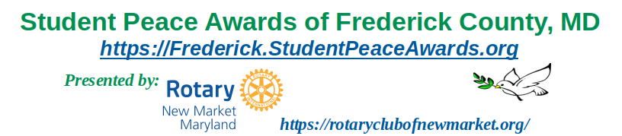
Nomination Form 2025 - 2026

PART 1: CONTACT INFORMATION FOR STUDENT AND SCHOOL
NAME OF SCHOOL ___________________________________________________
CONTACT PERSON'S NAME ____________________________________________
position ___________________________________________________
e-mail address ______________________________________________
phone number _______________________________________________
We will use the information you provide below for contacting the award recipient. The student’s name and peace-related activities will be published in the awards ceremony program and press releases.
AWARD RECIPIENT'S NAME ____________________________________________
home address ___________________________________________________
e-mail address ___________________________________________________
phone number ___________________________________________________
DESCRIPTION OF YOUR SCHOOL'S SELECTION PROCESS _________________________________________________________________________ _________________________________________________________________________ _________________________________________________________________________ _________________________________________________________________________ _________________________________________________________________________ _________________________________________________________________________
DATE AND TIME OF YOUR SCHOOL AWARDS/GRADUATION CEREMONY ____________________
We would be glad to send a member of our organization to your school to present the award, if that is permissible. Please let us know.
NAME OF YOUR STUDENT NEWSPAPER _____________________________________
CONTACT INFORMATION FOR THE NEWSPAPER _____________________________

Part 2: DESCRIPTION OF STUDENT'S PEACEMAKING CONTRIBUTIONS
Student’s name: ____________________________________________________

Please provide a letter telling us why you selected this student. Be sure to make clear how these activities support peacemaking, conflict resolution, and respect for all people. This letter will provide the description we will use in our awards ceremony.
Name and title of person submitting the description:
______________________________________________________

If the student's peacemaking efforts were done as part of an organization, include the name of the organization.
Name of organization, if applicable: _________________________________________

MAILING INFORMATION
Please send this form electronically by January 30, 2026 to: therotaryclubofnewmarket@gmail.com

This and other documents are also available on our website: https://frederick.studentpeaceawards.org/

